DSA-2000 Document No. 00020

Education and Public Outreach Plan

Akanksha Tiwary, Katie Jameson

Caltech

|  |  |  |  |  |  |  |  |  |  |  |  |  |
| --- | --- | --- | --- | --- | --- | --- | --- | --- | --- | --- | --- | --- |
| |  |  | | --- | --- | | Version: | 1 | | Version date: | 8/23/23 | | Original date: | 2023-08-23 | | Controlled document: | No | | WBS Level 2: | EPO–EPO | | Document type: | OTH–Other  Other | |
|  |

Revision History

| **Ver.** | **Date** | **Sections Affected** | **Reasons / Remarks** | **Author(s)** |
| --- | --- | --- | --- | --- |
| 1 | 2023-10-23 | All | Original |  |

Table of Contents

1 Introduction 3

2 Goals 4

2.1 Train the Next-Generation of STEM Workforce 5

2.1.1 Graduate Student Researchers 5

2.1.2 RadioWAVE Undergraduate Summer Research Program 5

2.1.3 Technical Internships 6

2.2. Foster a science-Informed Society 7

2.2.1. AstroTourism 8

2.2.2. K-12 Teacher Professional Development and Curriculum 8

3 Diversity and Inclusion 9

4 Evaluation 10

5 References 10

# Introduction

The DSA-2000 Education Programs and Outreach (EPO) efforts will build off the Owens Valley Radio Observatory's (OVRO) rich history in radio astronomy, instrumentation, and student training to improve the links between scientists, students, and society. Radio astronomy encompasses all the STEM skills that underpin a strong developed economy. Modern astronomers need knowledge in physics, mathematics, and computing; Developing, maintaining, and running radio telescopes require key skills in technology and engineering. The DSA-2000 is a transformational project for many reasons, including its commitment to tap into radio astronomy to inspire the next generation of scientists and engineers, and to develop a workforce with the skills needed to compete in the global economy.

Since the radio array is likely to be built in Nevada, our EPO efforts during the design and construction of the DSA-2000 will prioritize the needs of Nevadan students and communities. The state of Nevada has a compelling need for STEM education and workforce training. Nevada has distinct regional differences, both economically and demographically, making it simultaneously one of the most urban and most rural states in the nation. This diversity presents both challenges and opportunities for STEM education and workforce development. 1

The mission of the DSA-2000 EPO is to inspire and engage diverse communities with the wonders of cutting-edge radio astronomy. Close collaboration with relevant government, industry, academic and development partners, including local and traditional leadership, will ensure the sustainability of our EPO initiatives, which will be established to help expand Nevada's STEM-capable workforce, increase research competitiveness, and create a more scientifically literate society.

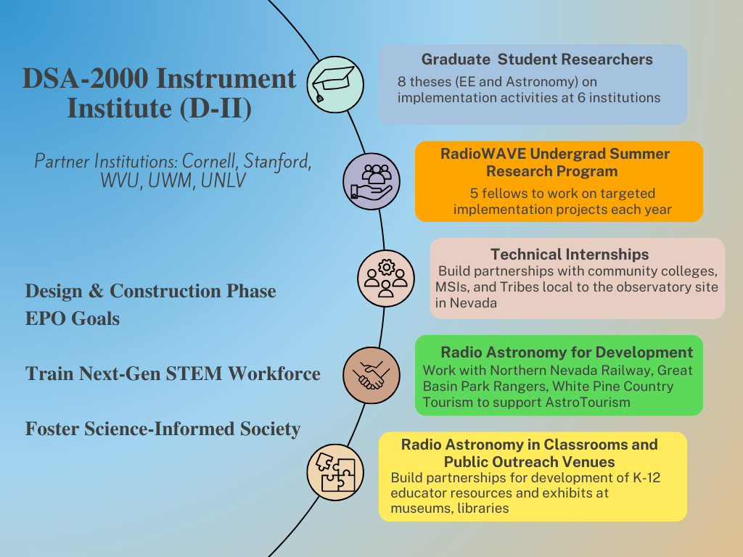

Fig 1. Overview of the DSA-2000 Education Programs and Outreach Efforts

# Goals

The goals of the DSA-2000 Education Programs and Outreach are:

**2.1** Train the next-generation of STEM Workforce by creating education and training programs that prepare students for the jobs of tomorrow

**2.2** Foster a science-informed society that appreciates astronomy and radio wave technology's impact on our daily lives and cosmic understanding

## Train the Next-Generation of STEM Workforce

The project will initiate the DSA-2000 Instrument Institute (D-II), building on the heritage

of the Radio Camera Initiative (RCI), to engage, train, and foster community among a diverse, distributed

student collective. The D-II will channel efforts at academic institutions in the US towards implementing

the DSA-2000 research infrastructure, and to simultaneously train a network of undergraduate

and graduate students.

OVRO has a proven >60-year record of student/postdoc involvement in the implementation and system-verification of ground-breaking radio astronomy research infrastructure. The design phase of the DSA-2000 has so far deeply involved three students and six postdocs, with training opportunities ranging from receiver and analog-signal-chain design, forward modeling of the radio camera data products, and the novel application of computer-vision techniques to interferometric images.

The D-II will be constituted the following three streams:

### 2.1.1 Graduate Student Researchers

Eight theses (EE and Astronomy) at six institutions will be based on implementation activities spanning the breadth of the DSA-2000 project, ranging from end-to-end signal chain verification to implementation of key post-processing pipelines. Students will validate their work using data from partial antenna arrays during construction.

### 2.1.2 RadioWAVE Undergraduate Summer Research Program

DSA-2000’s RadioWAVE program will be built into Caltech’s highly successful WAVE Fellows program; More than 90 percent of WAVE fellows, who are drawn from historically minoritized communities, enroll in graduate school. The WAVE Fellows program recognizes that diversity of background, experience, and thought is essential to achieving and maintaining scientific excellence. D-II will equally provide research experiences for STEM-focused students from community colleges and minority-serving institutions (MSIs) in Nevada.

Women and minorities often come about their interest and therefore opportunities to pursue STEM careers through a circular path, often outside the normal pipeline and disproportionately through paths that are typically not associated with matriculation in major graduate research institutions, such attending Minority Serving Institutions (MSIs) and two-year or community colleges. Community colleges, for example, often are seen by some minorities as the alternative pathway towards four-year colleges and universities. Historically Black Colleges and Universities (HBCU), Tribal Colleges and Hispanic Serving Institutions (HSI) are notable because they offer an alternative pathway to STEM careers.

Five RadioWAVE fellows will work on targeted implementation projects each year within the Caltech Cahill Radio Astronomy Lab, Receiver Lab, and the Software and Algorithms Lab, and at OVRO. Fellows will carry out the work over a 10-week period during the summer and submit two interim reports, a research abstract, and final paper. At the conclusion of the program, students give an oral or poster presentation at symposia modeled on a professional technical meeting.

In addition to engaging in a mentored research and engineering activities, RadioWAVE Fellows participate in:

* Weekly seminars by Caltech faculty & JPL scientists and engineers
* An academic and professional development series on developing a research career, graduate school admissions, effective writing and oral communications, and other topics of interest to future researchers
* Effective writing workshops
* Social and cultural activities
* Weekly small student-faculty dinners
* Special field trips

RadioWAVE is under development in partnership with the Caltech Student Faculty Programs (SFP) and Nevadan MSIs and community colleges (Table 1) for a pilot run in FY24.

|  |  |  |
| --- | --- | --- |
| **Institution** | **Category** | **Primary Contact** |
| University of Nevada, Las Vegas (UNLV) | MSI, AANAPISI, HSI | Yingtao Jiang,  *Professor, Associate Dean of Undergraduate Programs* |
| Truckee Meadows Community College  (TMCC) | MSI, HSI | Anne Flesher,  *Dean, Math and Physical Sciences Division* |
| College of Southern Nevada | MSI, AANAPISI, HSI | TBA |
| Western Nevada College, Carson City | MSI, HSI | TBA |
| Great Basin College | Community College | TBA |
| Nevada State College, Henderson | MSI, AANAPISI, HSI | TBA |

Table 1. Internship partners in Nevada

### 2.1.3 Technical Internships

The DSA-2000 will be a landmark facility for research and education in astronomy. The public and highly accessible nature of the data products represent a democratization of access to the radio sky. Design efforts have proceeded in close collaboration via contract with industry partners, including Praxis Optical Networks (site infrastructure), TEAM Environmental and WSP (permitting), Minex Engineering Corporation (antennas), and Real-Time Radio Systems and Nvidia (radio camera processor).

DSA-2000 is building partnerships (Table 1) with community colleges, MSIs, and Tribes local to the observatory site to provide technical internships for students from diverse backgrounds to directly assist with implementation. From our initial discussions with UNLV and TMCC, we anticipate collaborative development of tailored internship opportunities, including for-credit internships. These Computing and Engineering Technology internships would lead to careers in electronics, information technology, and facilities maintenance, while also helping MSIs increase student engagement and retention. We will recruit interns to continue on with the DSA-2000 project through implementation and into operation.

Student training will be facilitated by synergistic activities of the D-II, in addition to sustained research

mentorship. We will build on the highly successful online RCI seminar series with regular virtual seminars by invited and internal speakers, as well as “Ask me anything” sessions with members of the DSA-2000 engineering staff. D-II members will convene for annual conferences to present their research.

The D-II synergistic activities in student training are modeled on well-tested programs that key team members are part of, which involve students with cutting-edge radio astronomy instrumentation (Pulse@Parkes, the Arecibo Remote Command Center, and the Pulsar Search Collaboratory).

## 2.2. Foster a Science-Informed Society

Too few Nevadans consider STEM careers in large part because they are not exposed to STEM education as students or are not made aware of the many exciting career opportunities in STEM available to those with some postsecondary education.2 Moreover, the 2020 Nevada Statewide Plan for the Improvement of Pupils places a greater emphasis on collaboration than ever before, recognizing that collective impact is essential to student success. By working together as a system, Nevada's education stakeholders amplify their impact and achieve more than they would individually.

From outreach activities and lesson plans that encourage curiosity in our programs, to informal education offerings that provide opportunities for learning outside the classroom, DSA-2000 EPO aspires to reach and engage diverse members of society —from preschoolers to retirees. Our outreach initiatives will provide unique opportunities for our researchers to promote their work to diverse audiences.

We are investigating a broad range of top-down and bottom-up STEAM networks to help us bring the excitement of contemporary science to the general public, school students and teachers, and to significantly extend our reach throughout the lifecycle of the project. For example, Pathways to STEM Nevada (formerly Nevada STEM Pipeline) was developed as a resource to engage students, teachers, parents, and the community in STEM education and employment. The effort is at the forefront to increase the number of students interested in pursuing college degrees with the overarching goal of strengthening future workforce and economic development in the state. The DSA-2000 will advertise on the user-friendly web portal that provides information on various programs, resources and employment opportunities for K-20 students, parents, and the community. DSA-2000 will also participate in annual community events such as Northern Nevada Science and Technology Festival and Great Basin Astronomy Festival.

Our strategic partnerships (Table 2) aimed towards equity and impact will help us with our goal of fostering a science-informed society. Communication will take place by telecon or video conferencing or in-person meetings where possible, and dissemination will occur by web tools.

|  |  |  |  |
| --- | --- | --- | --- |
| **Organization** | **EPO Category** | **Audience** | **Primary Contact** |
| Caltech Student Faculty Programs | Formal Learning | STEM Undergraduates | Carol Casey, Associate Director |
| Northern Nevada Railway | Informal Learning | Kids, young adults, general public | Mark Basset, Executive Director |
| White Pine County Tourism and Recreation | Public Outreach | Local community and tourists | Kyle Horvath,  Tourism Director |
| Great Basin National Park | Informal Learning | Kids, young adults, general public | TBA, Park Astronomy Ranger |
| Discovery Museum | Informal Learning | Kids, young adults, general public (Exhibits) | TBA |
| Desert Research Institute | Formal + Informal Learning | K-12 Educators  (Teaching resources) | TBA |
| Great Basin Native Artists | Public Outreach | Artists | TBA |

Table 2. Outreach and Engagement Partners in Nevada

### 2.2.1. Astrotourism

The efforts to promote education in STEM and socio-economic development would be translated by Astrotourism projects with Northern Nevada Railway and White Pine County Tourism and Recreation. Launched in 2009, the Northern Nevada Railway's Star Train Program is a unique and educational experience that offers passengers the chance to learn about the stars and planets while enjoying a scenic train ride, from the Railroad Museum in Ely through the Nevada desert. The popular program is led by experienced Great Basin National Park rangers, who share their knowledge of the night sky with passengers in a fun and informative way. In the interest of promoting literacy in STEAM, local history, and tourism in the region, the development of a visitor center is under consideration.

### 2.2.2. K-12 Teacher Professional Development and Curriculum

The Desert Research Institute (DRI) is a recognized world leader in basic and applied environmental research, serving as the non-profit research arm of the Nevada System of Higher Education. DRI’s Green Boxes initiative are self-contained teaching kits that provide educators with two or more weeks of lesson plans along with all of the supplies necessary to conduct each activity. Every box uses active learning strategies to engage students in hands-on projects that foster critical thinking and problem-solving skills. These lessons are designed to enhance student literacy in various STEM subject areas, from introduction to multiwavelength astronomy, water conservation in the Desert, to investigation of the four seasons as citizen scientist. Green Boxes are available to all formal and informal educators in Nevada, free of charge.

DSA-2000 intends to work with DRI Green Boxes initiative to introduce the radio-frequency window, discovered some 75 years ago, that served to transform our understanding of the universe. Radio astronomy is not just a collection of results, but also a rapidly growing field concerned with the instruments used to gather data, including instrumental properties, advantages, and limitations.

It stands ready today to assist STEM educators at all levels as a valuable teaching tool. By describing cosmic phenomena different from anything in our earthly experience, coupled with dimensions that transcend human comprehension, it should arouse in students a deep curiosity, hopefully, to the point where they will want to learn more.6

# Diversity and Inclusion

Caltech’s mission is to expand human knowledge and benefit society through research integrated with education. This depends on the pursuit of diversity, equity, and inclusion in all aspects of institutional life. Pedagogical and research practices that engage, motivate and support students from all backgrounds are implemented.

For example, the Caltech Student-Faculty Programs (SFP) office and the Caltech Center for Inclusion and Diversity (CCID) provide training to Caltech faculty, postdocs, and graduate students to promote the use of effective, inclusive approaches to teach, mentor and advise. The CCID additionally provides education, advocacy, and allyship across the Caltech community. Institute-wide community-building programs, such as the First-Year Success Research Institute, Graduate Summer Research Institute, affinity organizations, and employee resource groups have been initiated. At an organizational level, the President’s Diversity Council and Divisional DEI Committees (one chaired by the PI) work to advance diversity, equity, and inclusion in support of Caltech’s mission.

The DSA-2000 fosters and supports diversity in STEM careers by incorporating purpose-built hiring practices. At a high level, these include: targeted advertising with professional societies, including AAS and IAU, and society chapters that support under-represented groups; flexible workplace practices to support those with caretaker responsibilities or disabilities; rigorous application of rubrics in candidate assessment; and a requirement for gender-representative shortlists with a target of at least 40% women and 40% men.

# Evaluation

Assessment of D-II activities will be accomplished through monitoring of participant experiences, performance, and future trajectories. Feedback mechanisms will include longitudinal surveys and discussions at the annual conferences, a joint review of annual committee reports on graduate student progress, and existing assessment procedures in the Caltech WAVE program and Caltech Center for Teaching, Learning, and Outreach (CTLO). Evaluation metrics and methodologies for our outreach programs will be developed in collaboration with subject matter experts (CTLO) and program stakeholders to ensure that they are aligned with program goals and objectives. Caltech currently tracks gender and race/ethnicity (both self-identified) as the main demographics.

# References

1. <https://stempathways.epscorspo.nevada.edu/>
2. STEM Strategic Plan for Nevada 2017
3. Nevada Department of Education Statewide Plan for the Improvement of Pupils 2020
4. Nevada STEM Framework 2024
5. Derman, Samuel. “Need a Classroom Stimulus? Introduce Radio Astronomy.” *Physics Teacher* 48, no. 4 (April 2010): 251–55. doi:10.1119/1.3361996.
6. <https://www.dri.edu/science-alive/green-boxes/>